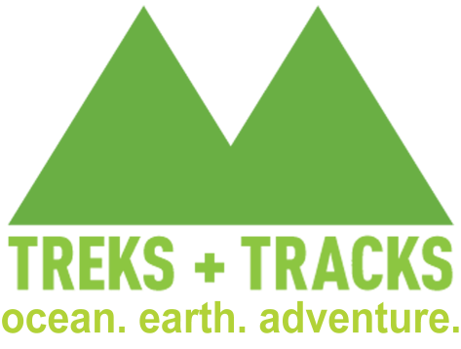

Backpacking Registration & Medical Questionnaire

Trip Date: ________________________________

Applicant Name ___________________________ Phone __________________

Mailing Address ____________________________ Email _________________

City, State, Zip ____________________________________________________

**This form must be emailed to info@treksandtracks.com prior to your trip.**

Our backcountry trips take place in remote wilderness, where rescue is difficult and medical care is hours away. Our outings require you to perform at a high level of physical activity. We use your answers on this form to make sure you’re signed up for the most appropriate trip. Omissions on this questionnaire may have a negative impact on you and the rest of your group. All information you provide is kept confidential. Please completely answer all of the questions on this form. Thank you.

Birthdate __ / __ / ____ Gender ________ Height ______ Weight _______

**Fitness**

Please describe your level of physical conditioning. Include what types of exercise you do and how often you do each activity.

What kind of experience do you have with similar activities or trips?

Do you have a fear of heights or exposed places (please **bold** your answer throughout the rest of the form when it applies)? Yes No

**Equipment**

Treks and Tracks provides equipment for you. In order to help your guide prepare, please mark equipment items that you wish to have provided for you with a capitol “X”.

Backpack

Tent (4-person - will be shared with other members of the group)

Sleeping Bag

Sleeping pad

**Dietary Restrictions/Preferences**

Do you have any Dietary restrictions or preferences? Vegetarian? Vegan? Food allergies/intolerance?

In the morning do you prefer: Coffee Tea Hot Chocolate None Other ___________

**Medical History** (Do you currently have or have you ever had any of the following).

Asthma/ Respiratory Illness Yes No

If yes, do you carry an inhaler? Yes No

Diabetes Yes No

Seizures/Epilepsy Yes No

Cardiovascular Disease Yes No

Hypertension/High blood pressure Yes No

Joint (hip knee ankle shoulder etc.) or back injuries (including sprains) Yes No

Bleeding or blood disorders Yes No

Dizziness or fainting episodes Yes No

Do you see a Medical/Physical Specialist of any kind Yes No

Any other condition that would affect your performance or health in the backcountry Yes No

Please explain any yes responses in the space below – including approximate dates and current status.

Are you pregnant? Yes No

**Allergies** (are you allergic to any of the following?)

Medications Yes No

Insect stings Yes No (If yes, we strongly recommend that you carry medication.)

Food allergies Yes No

Other Yes No

Please explain any yes responses in the space below – including description of allergic response.

**Medications**

Are you currently taking any medications? Yes No

If yes, please list medication, dosage, and condition for which you are taking the medication:

**Photograph Authorization** (optional)

Occasionally we would like to use trip photographs for marketing or advertising purposes. If you would be willing to have a picture published in this way, please sign below.

I agree that any photographs taken by Treks and Tracks of me or my minor child during our trip shall be property of Treks and Tracks and its and may be used by Treks and Tracks at its discretion, for any publicity, marketing

and/or advertising purposes, and I hereby consent to and authorize such use without restriction.

Signature (Parent/Legal Guardian if under 18): _____________________________

Date: _______________